Group member names: Michael Eastman, Mitchell Whyte, Alexander Overley, Narbada Acharya, David Topin, Maurice Cardwell

**Exercise 2: Problem Solving** (5 points)

**Instructions:**

1. This is a group assignment. You only need to submit one solved exercise per group.
2. Provide your responses on this file, save it, and upload the file to the appropriate assignment response in blackboard.
3. You may upload as many attempts as you may like. Please note that only the most recent file uploaded file would be graded.
4. Do not handwrite any responses.
5. If you have any additional information you would like me to know about this assignment, you may provide that to me at the end of this document as a note.

**Identify and explain at least two serious data redundancy problems exhibited by the file structure in the table below:**

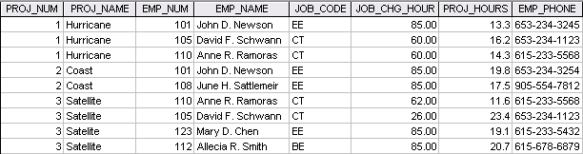

**Problem 1:**

The PROJ_NUM and PROJ_NAME refer to the same thing: “What is the project?”

**Problem 2:**

A serious redundancy problem is that EMP_NAME, EMP_NUM, and EMP_PHONE are repeated and the table structure allows this redundancy. Ramorses and Schwann are the primary examples as they were sorted by EMP and instead of th